Kuburnetes Task 3

- Create a ClusterIP service for an Apache web server pod.
- Expose an Nginx pod externally using a NodePort service.
- Deploy a ReplicationController to maintain 3 replicas of an Nginx pod.
- Scale the ReplicationController from 3 replicas to 5 replicas.
- Create a ReplicaSet to manage pods based on multiple labels (prod and test).
- Deploy a ReplicaSet that excludes pods with the label backend.
- Test load balancing across multiple pods using a NodePort service.
- Delete a ReplicationController without affecting the running pods.

Task 1
Task
Create a ClusterIP Service for an Apache web server Pod.
We'll create:
- Apache Pod → apache-pod
- ClusterIP Service → apache-service
- Apache listens on port 80
- Service exposes port 80

Step 1 — Create Apache Pod YAML
On the Master:
nano apache-pod.yml
Paste:apiVersion: v1
kind: Pod
metadata:
name: apache-pod
labels:
app: apache
spec:
containers:
- name: apache
image: httpd
ports:
- containerPort: 80
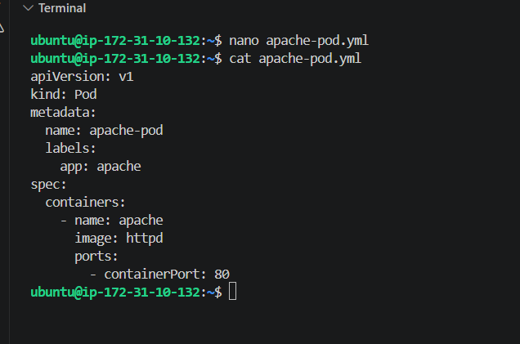
Step 2 — Create the Pod
kubectl apply -f apache-pod.yml
Expected:
pod/apache-pod created
Check:
kubectl get pod apache-pod
Wait for:
apache-pod 1/1 Running
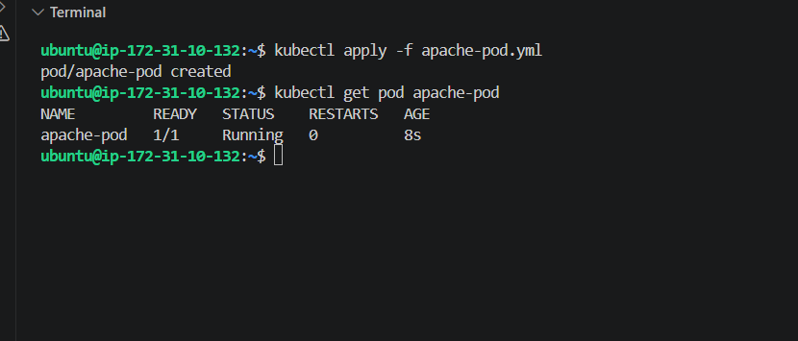
Step 3 — Create ClusterIP Service YAML
nano apache-service.yml
Paste:
apiVersion: v1
kind: Service
metadata:
name: apache-service
spec:
type: ClusterIP
selector:
app: apache
ports:
- protocol: TCP
port: 80
targetPort: 80
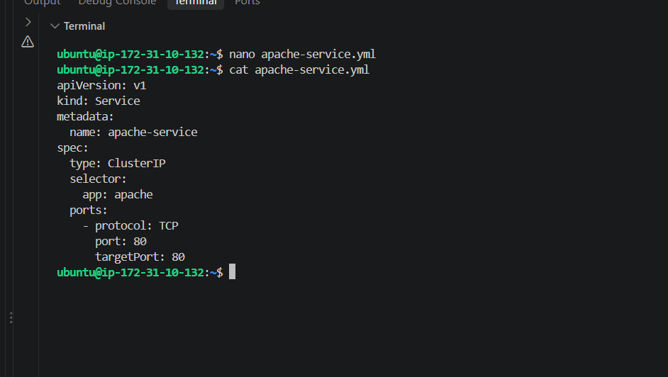
Step 4 — Create the Service
kubectl apply -f apache-service.yml
Then:
kubectl get svc apache-service
Expected:
NAME TYPE CLUSTER-IP EXTERNAL-IP PORT(S)
apache-service ClusterIP 10.xxx.xxx.xxx <none> 80/TCP
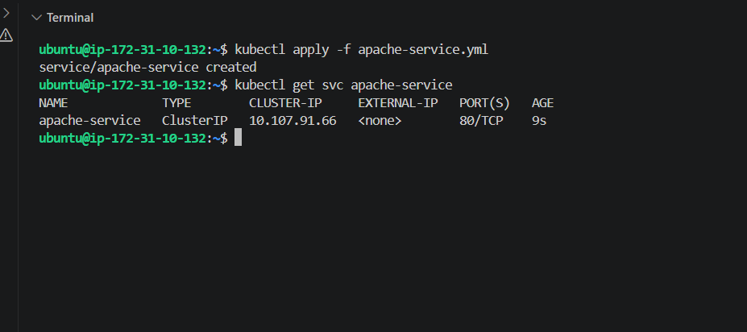
Step 5 — Verify the Service has an endpoint
kubectl get endpoints apache-service
Expected something similar to:
apache-service 10.244.x.x:80
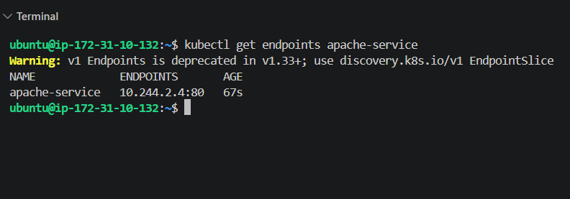
Task 2 — Expose Nginx using NodePort
We'll create:
- Nginx Pod → nodeport-nginx
- NodePort Service → nginx-nodeport
- Pod port → 80
- Service port → 80
- NodePort → 30080
1. Create Nginx Pod
nano nodeport-nginx.yml
Paste:
apiVersion: v1
kind: Pod
metadata:
name: nodeport-nginx
labels:
app: nodeport-nginx
spec:
containers:
- name: nginx
image: nginx
ports:
- containerPort: 80
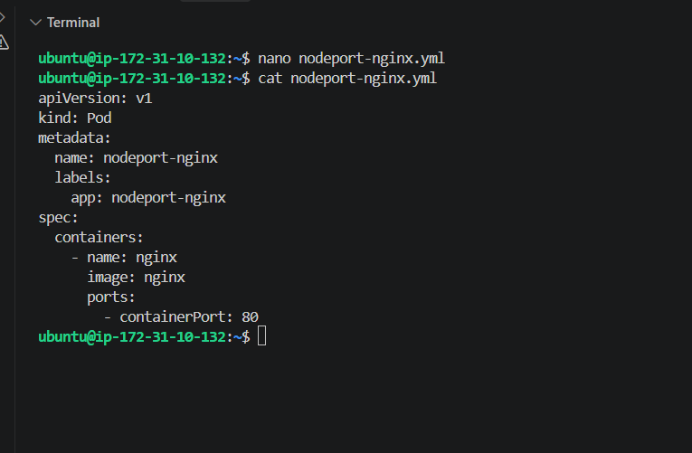
Create it:
kubectl apply -f nodeport-nginx.yml
Verify:
kubectl get pod nodeport-nginx
Wait for:
nodeport-nginx 1/1 Running
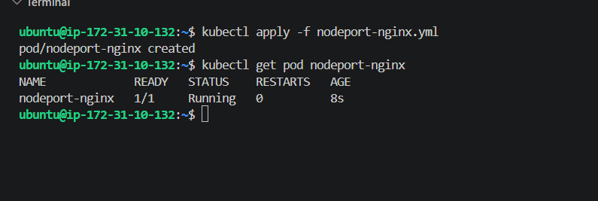
2. Create NodePort Service
nano nginx-nodeport.yml
Paste:
apiVersion: v1
kind: Service
metadata:
name: nginx-nodeport
spec:
type: NodePort
selector:
app: nodeport-nginx
ports:
- protocol: TCP
port: 80
targetPort: 80
nodePort: 30080
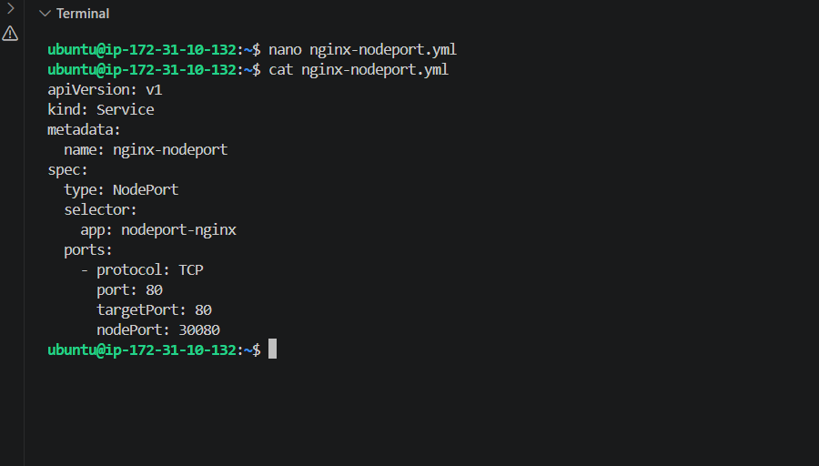
Create:
kubectl apply -f nginx-nodeport.yml
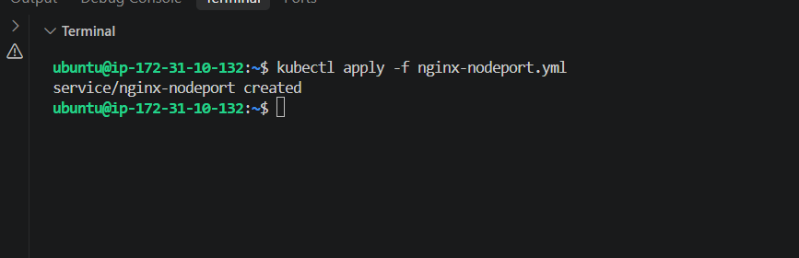
3. Verify Service
kubectl get svc nginx-nodeport
Expected:
NAME TYPE CLUSTER-IP EXTERNAL-IP PORT(S)
nginx-nodeport NodePort 10.x.x.x <none> 80:30080/TCP
Also check:
kubectl get endpoints nginx-nodeport
Expected:
nginx-nodeport 10.244.x.x:80
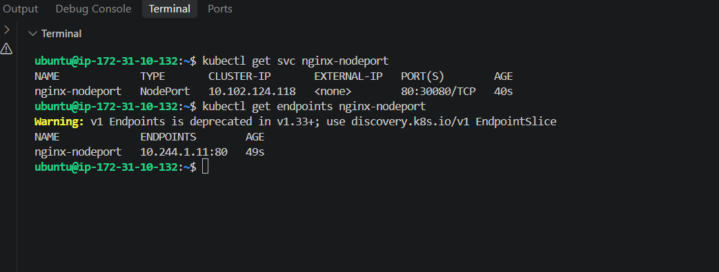
Task 3 — ReplicationController with 3 Nginx replicas
Now create the ReplicationController.
1. Create the YAML
nano nginx-rc.yml
Paste this complete file:
apiVersion: v1
kind: ReplicationController
metadata:
name: nginx-rc
spec:
replicas: 3
selector:
app: nginx-rc
template:
metadata:
labels:
app: nginx-rc
spec:
containers:
- name: nginx
image: nginx
ports:
- containerPort: 80
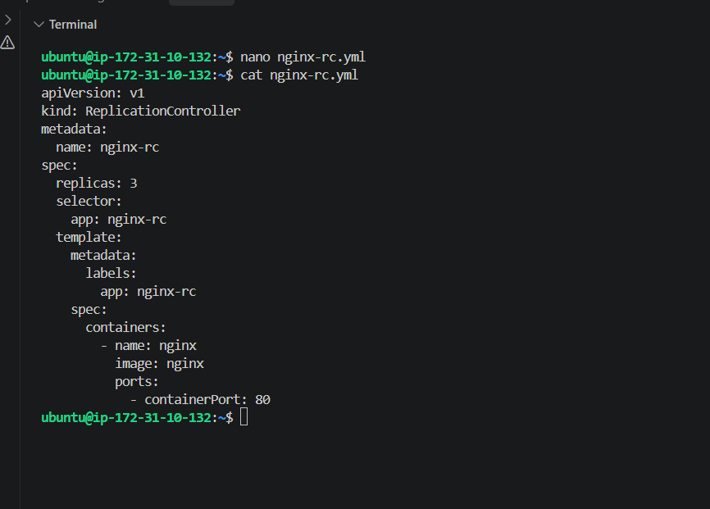
2. Create the ReplicationController
kubectl apply -f nginx-rc.yml
3. Check RC
kubectl get rc
Expected:
NAME DESIRED CURRENT READY AGE
nginx-rc 3 3 3 ...
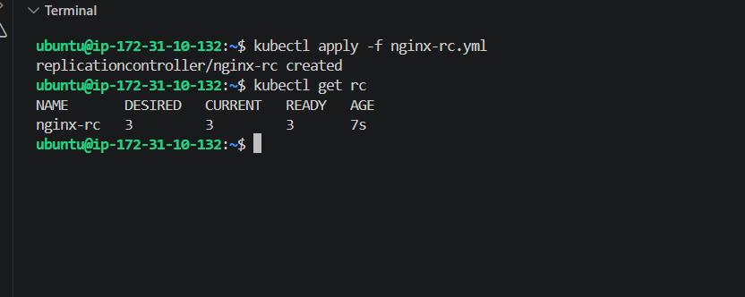
4. Check the 3 Pods
kubectl get pods -l app=nginx-rc -o wide
You should see 3 nginx Pods, preferably distributed across your workers.
5. Verify RC details
kubectl describe rc nginx-rc
Look for:
Replicas: 3 current / 3 desired
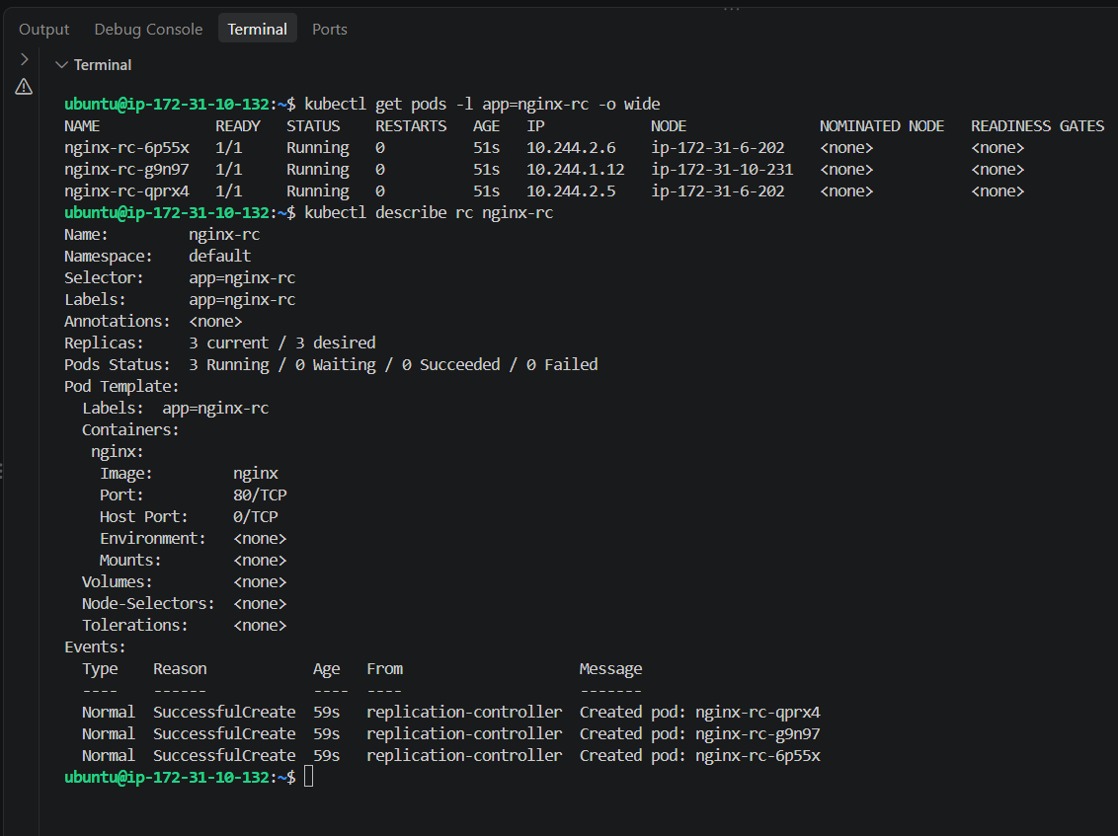
Task 4 — Scale RC from 3 → 5
Run:
kubectl scale rc nginx-rc --replicas=5
Then verify:
kubectl get rc nginx-rc
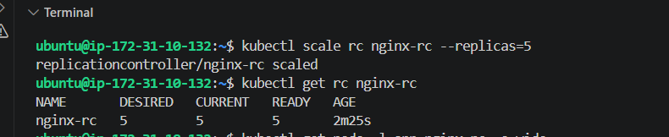
And:
kubectl get pods -l app=nginx-rc -o wide
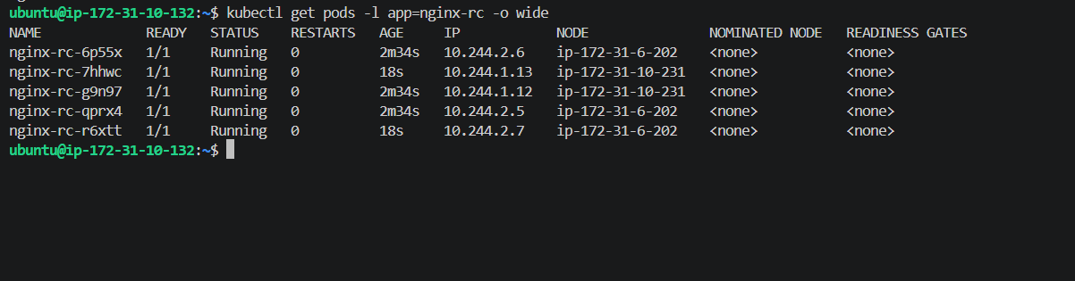
Task 5 — ReplicaSet with multiple labels
Now we'll create a ReplicaSet that selects Pods using multiple labels: environment=prod and environment=test.
Create the file:
nano nginx-rs.yml
apiVersion: apps/v1
kind: ReplicaSet
metadata:
name: nginx-rs
spec:
replicas: 3
selector:
matchLabels:
app: nginx-rs
matchExpressions:
- key: environment
operator: In
values:
- prod
- test
template:
metadata:
labels:
app: nginx-rs
environment: prod
spec:
containers:
- name: nginx
image: nginx
ports:
- containerPort: 80
Paste this complete YAML: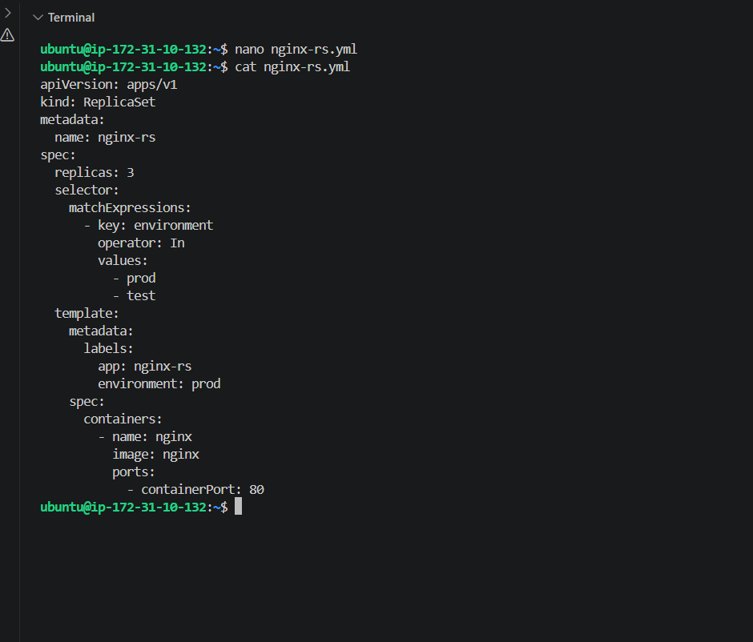
Apply:
kubectl apply -f nginx-rs.yml
Check ReplicaSet:
kubectl get rs
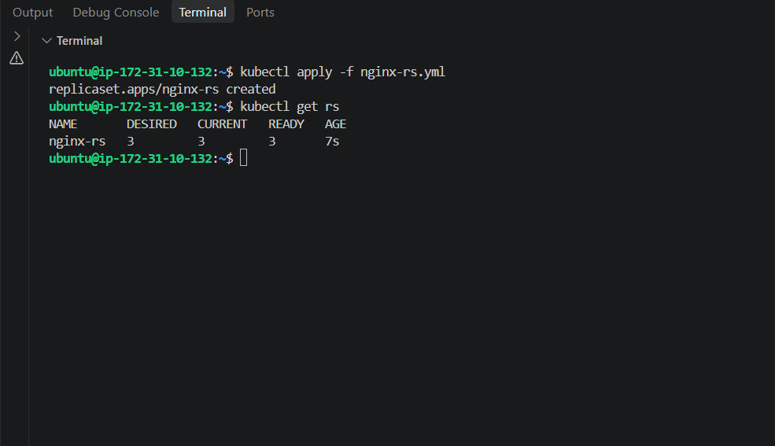
Then:
kubectl get pods -l app=nginx-rs --show-labels
You should get 3 Pods, with the template label:
environment=prod
Then:
kubectl get pods -l app=nginx-rs --show-labels
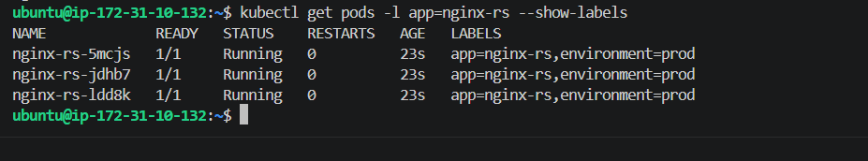
Task 6 — ReplicaSet excluding backend Pods
Now we'll create a ReplicaSet that selects Pods without the backend label.
1. Create the YAML
nano nginx-rs-exclude-backend.yml
Paste the complete file:
apiVersion: apps/v1
kind: ReplicaSet
metadata:
name: nginx-rs-exclude-backend
spec:
replicas: 3
selector:
matchLabels:
app: nginx-exclude-backend
matchExpressions:
- key: role
operator: NotIn
values:
- backend
template:
metadata:
labels:
app: nginx-exclude-backend
role: frontend
spec:
containers:
- name: nginx
image: nginx
ports:
- containerPort: 80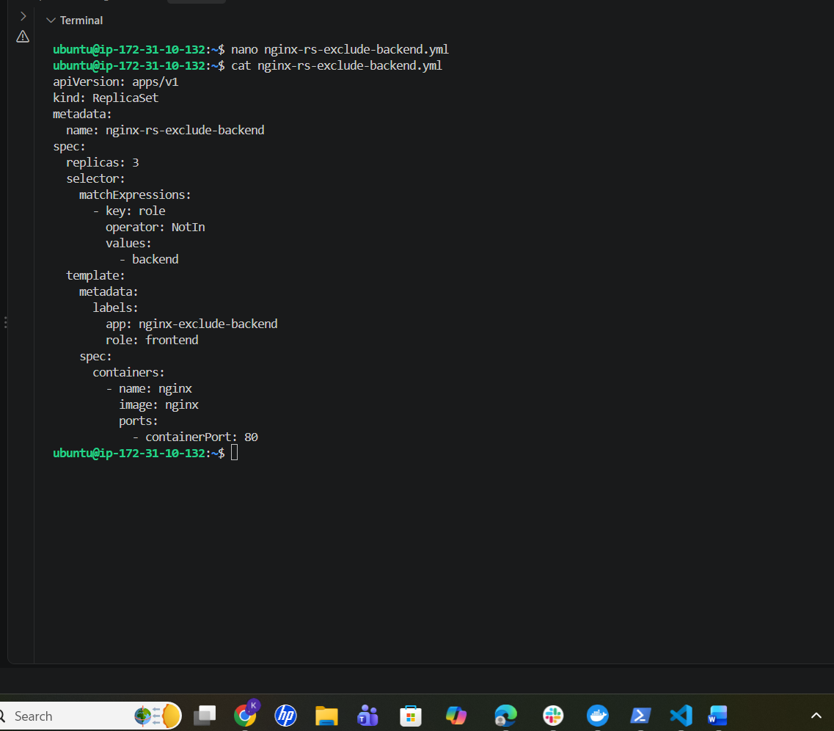
2. Apply
kubectl apply -f nginx-rs-exclude-backend.yml
3. Verify
Then:
kubectl apply -f nginx-rs-exclude-backend.yml
Verify:
kubectl get rs nginx-rs-exclude-backend
Then:
kubectl get pods -l app=nginx-exclude-backend --show-labels
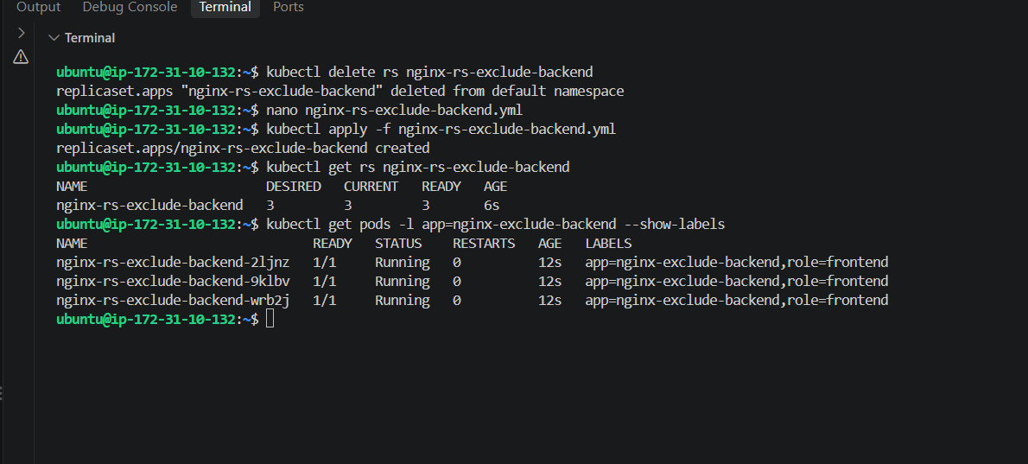
Task 7 — Test Load Balancing Across Multiple Pods Using NodePort
We already have the nginx-nodeport Service from Task 2, but its original Pod was deleted.
First, recreate the NodePort Nginx Pod.
1. Recreate NodePort Pod
nano nodeport-nginx.yml
Use:
apiVersion: v1
kind: Pod
metadata:
name: nodeport-nginx
labels:
app: nodeport-nginx
spec:
containers:
- name: nginx
image: nginx
ports:
- containerPort: 80
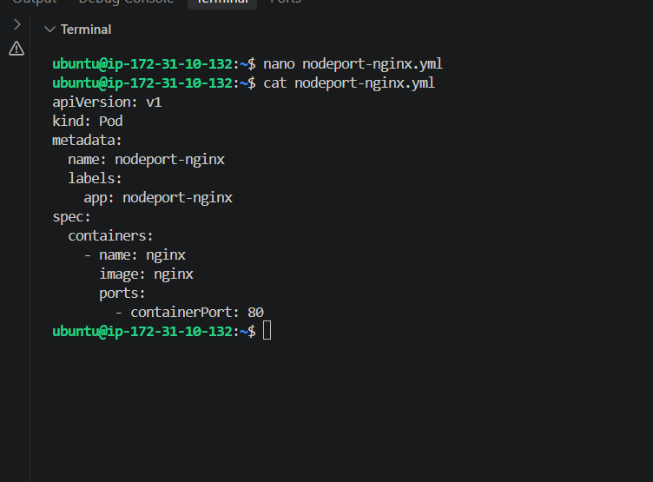
Apply:
kubectl apply -f nodeport-nginx.yml
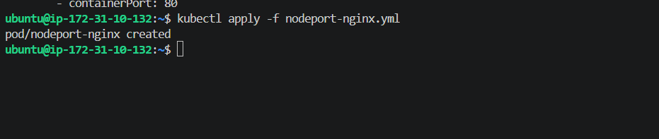

2. Check the existing Service
kubectl get svc nginx-nodeport
Expected:
nginx-nodeport NodePort ... 80:30080/TCP
Check endpoint:
kubectl get endpoints nginx-nodeport
Expected:
10.244.x.x:80
We Got error :
the Service is still pointing to only one Pod:
nginx-nodeport 10.244.1.18:80
For Task 7, we need it to point to the 5 nginx-rc Pods.
1. Check selector
Run:
kubectl get svc nginx-nodeport -o yaml
Look for:
selector:
app: ...
If it still says:
app: nodeport-nginx
change it with this direct command:
kubectl patch svc nginx-nodeport -p '{"spec":{"selector":{"app":"nginx-rc"}}}'
2. Verify endpoints
Then run:
kubectl get endpoints nginx-nodeport
You should now see 5 IP addresses, corresponding to your 5 RC Pods:
10.244.1.12:80
10.244.1.13:80
10.244.2.5:80
10.244.2.6:80
10.244.2.7:80
the Service selector is still:
selector:
app: nodeport-nginx
So it only selects the nodeport-nginx Pod.
Change the selector
Run this:
kubectl patch svc nginx-nodeport -p '{"spec":{"selector":{"app":"nginx-rc"}}}'
Then verify:
kubectl get svc nginx-nodeport
And:
kubectl get endpoints nginx-nodeport
You should now see 5 endpoints, because your nginx-rc has 5 Pods.
Also run:
kubectl get pods -l app=nginx-rc -o wide
Expected
Service:
nginx-nodeport NodePort ... 80:30080/TCP
Endpoints should contain 5 addresses:
10.244.1.x:80
10.244.1.x:80
10.244.2.x:80
10.244.2.x:80
10.244.2.x:80
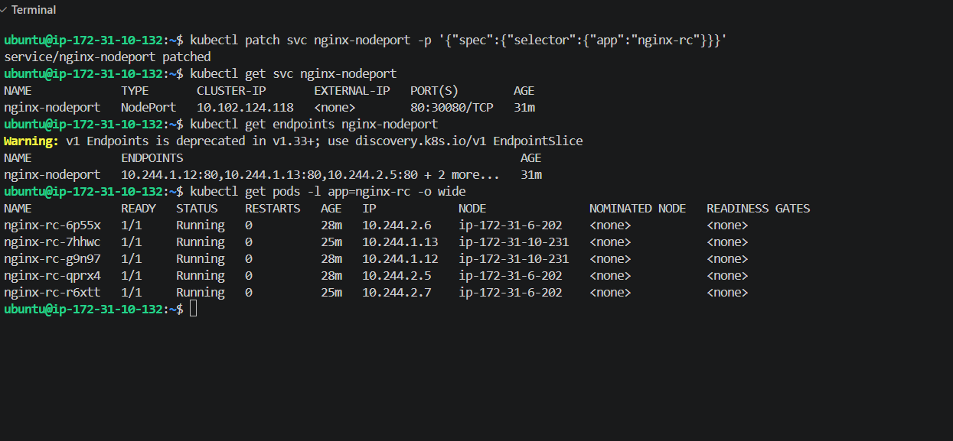
So the load-balancing path is:
Client
↓
EC2 Node :30080
↓
nginx-nodeport Service
↓
┌───────────────┬───────────────┬───────────────┐
Pod 1 Pod 2 Pod 3 ...
nginx-rc nginx-rc nginx-rc
Now test NodePort
From the Master, first get its private IP:
hostname -I
Then test the NodePort through the Master:
curl http://172.31.10.132:30080
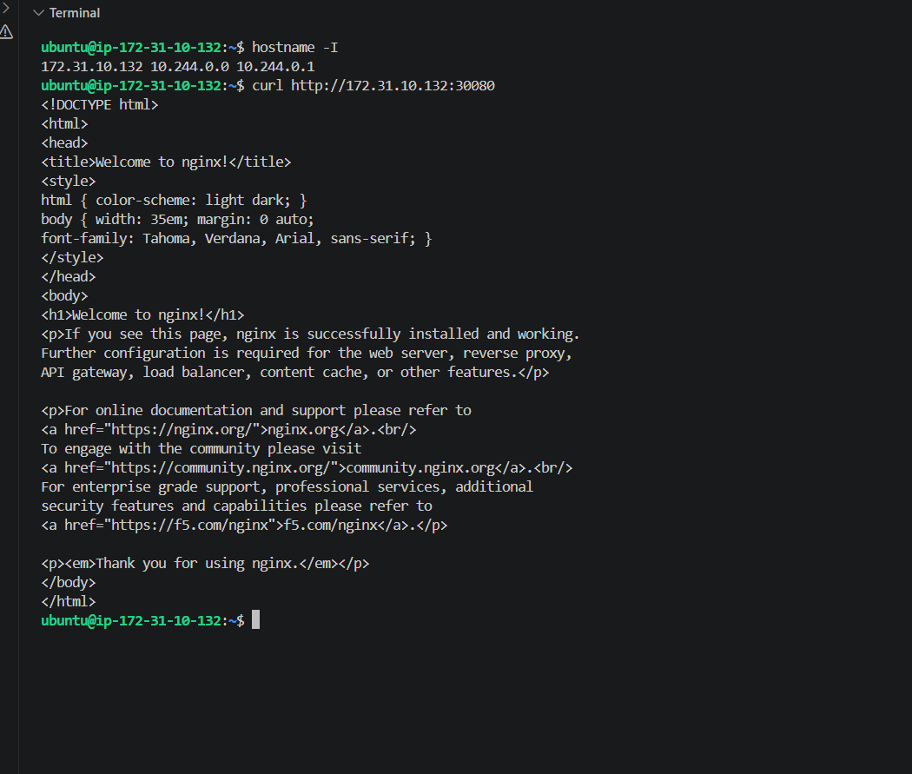
Your NodePort is working:
172.31.10.132:30080
↓
nginx-nodeport Service
↓
5 nginx-rc Pods
↓
Nginx response
And curl returned:
Welcome to nginx!
So the NodePort successfully forwarded traffic to the backend Pods.

Task 8 — Delete ReplicationController without deleting Pods
The requirement is:
Delete the ReplicationController, but keep its existing Pods running.
Normally:
kubectl delete rc nginx-rc
would also delete the Pods managed by it.
So we need to use:
--cascade=orphan
1. First verify the 5 Pods
kubectl get pods -l app=nginx-rc
You should see 5 Pods.
2. Delete the RC but orphan the Pods
kubectl delete rc nginx-rc --cascade=orphan
Expected:
replicationcontroller "nginx-rc" deleted
3. Verify RC is gone
kubectl get rc
nginx-rc should no longer appear.
4. Verify the 5 Pods are still running
kubectl get pods -l app=nginx-rc -o wide
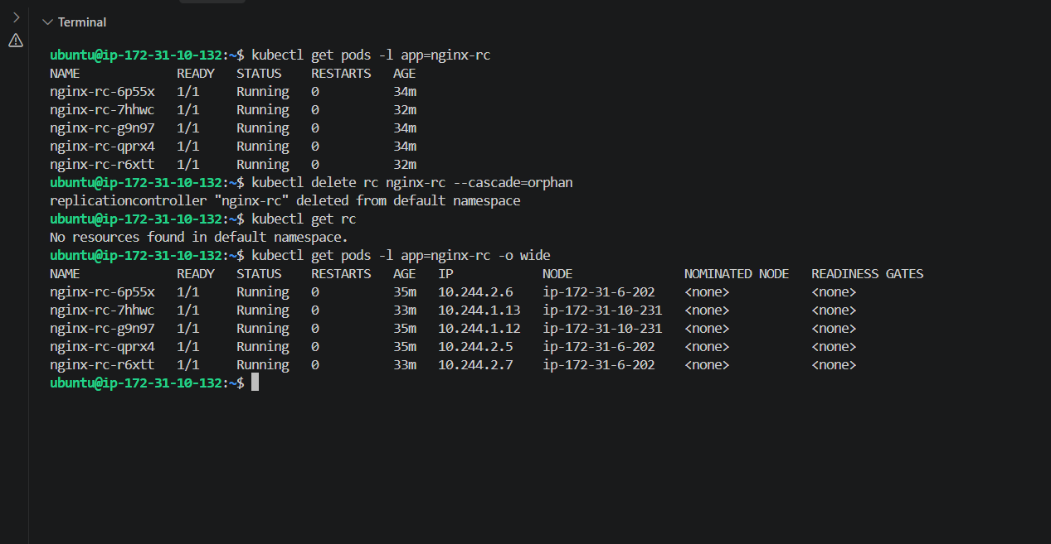
5. Verify NodePort still has the Pods
Because our NodePort Service uses:
selector:
app: nginx-rc
run:
kubectl get endpoints nginx-nodeport
The 5 Pod IPs should still be listed.
6. Test NodePort again
curl http://172.31.10.132:30080
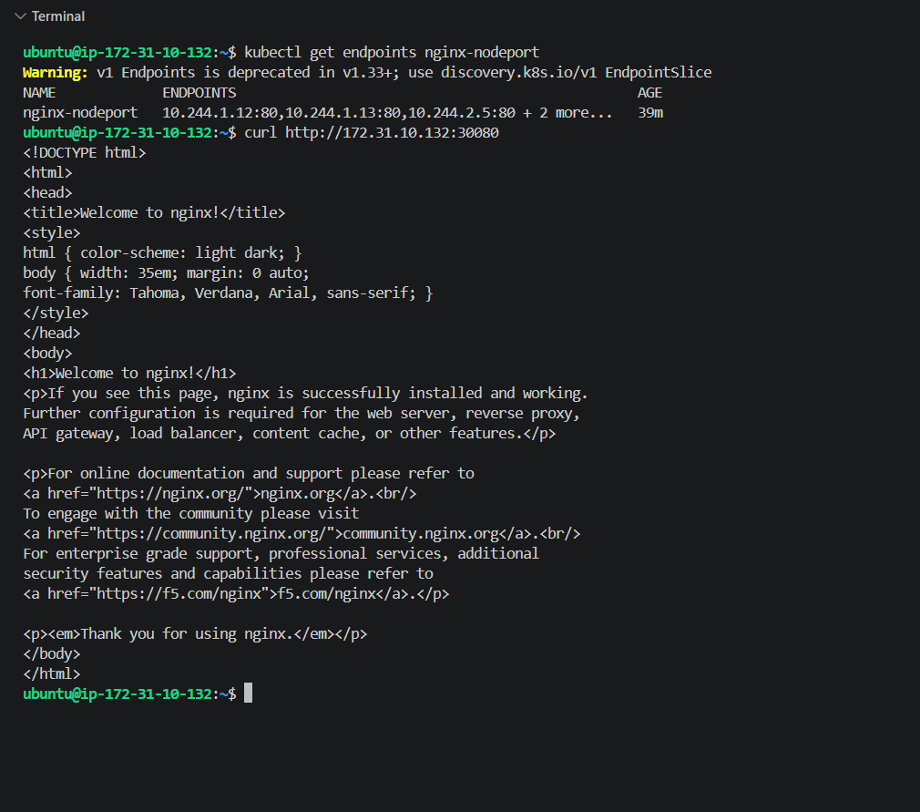
Delete RC but keep Pods
Run:
kubectl get rc nginx-rc
Then:
kubectl get pods -l app=nginx-rc
If the RC and 5 Pods are present, run:
kubectl delete rc nginx-rc --cascade=orphan
Then verify the RC is gone:
kubectl get rc
And verify the 5 Pods remain:
kubectl get pods -l app=nginx-rc -o wide
Finally:
kubectl get endpoints nginx-nodeport
and:
curl http://172.31.10.132:30080
Expected result
nginx-rc
should be gone, but the 5 nginx Pods should still be Running.
The NodePort should also continue returning:
Welcome to nginx!
